An Evening Talk with Boung-Kil Juong
On March 12, Thursday, 6 – 8:30 PM
A watercolor landscape painter from Korea, Boung-Kil Juong, will give a presentation on March 12, Thursday, from 6 – 8:30 PM at the Fairborn Art Association Gallery, 221 N. Central Ave., Fairborn, Ohio. He will talk about his artistic journey and demonstrate the landscapes he so loves to paint. Misuk Goltz took a one week private lesson from him in Jae Cheun City, Korea from January 2-8 this year and she will be hosting his stay in the US, translating and assisting with his presentation. The lecture is open to anyone who is interested in learning about Juong’s painting. The admission fee for the evening is $10, which includes Korean snacks. If you are planning to attend, or if you have any questions, call or email Misuk Goltz, 2489 Sherbourne Way, Xenia OH 4538, (937) 352-6711, mgoltz@woh.rr.com.
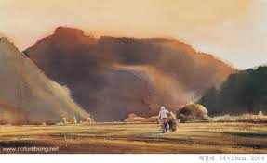
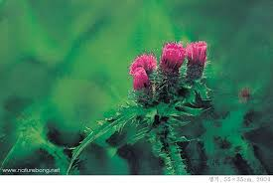
Boung-Kil Juong was born in South Korea and studied art from high school through college. He has been painting watercolors for the past 35 years and serves important positions in the Korean Watercolor Society and various educational associations. He has been teaching and serving as a juror for many art competitions. He also is regarded as a respected watercolor artist in China and he has held many exhibitions in various Chinese cities.
“My painting begins the moment my eyes land on nature when I visit the country side and mountains. I visit them as soon as the day breaks so I can listen to every bit of their thoughts and voices. I diligently look for changes in their sounds and colors. Without knowing nature, I don’t think I can paint, even a fraction.”

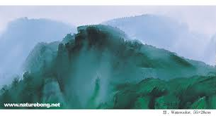
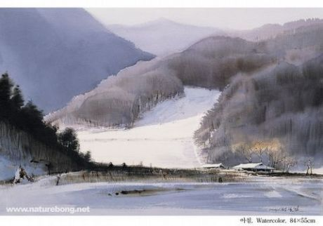
Juong is also scheduled to present a three day workshop from March 9 -11 at the Fairborn Art Association Gallery.

