Presented by Fairborn Art Association
Nov. 2nd to 5th (M – Th) 2015, 9 AM to 4 PM daily at the Fairborn Art Association Gallery, located in the rear of the Fairborn Senior Apartment Building, 221 N. Central Ave, Fairborn, OH

Watercolor Workshop with Mark Mehaffey, AWS DF, NWS, TWSA Master
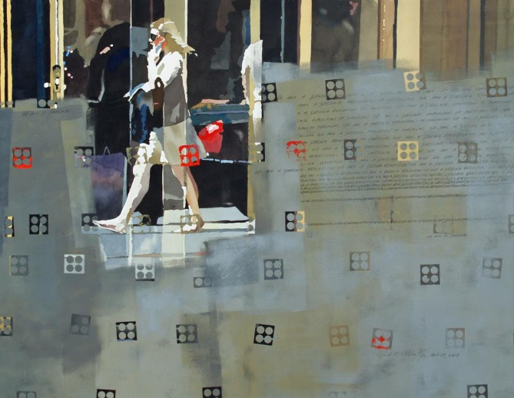
In this 4-day workshop, Participants will create paintings using the elements of shape, line, value and color to simplify subject and use a variety of color plans to create emotion and mood. Discussion of content, the importance of color schemes and line quality will also be discussed. Participants will also work intuitively with shape, color, line and especially texture to produce an abstraction with a personal focus and a representational work based on personal reference choices. All levels are welcome as long as everyone is comfortable with their materials.

You will sure walk away from this workshop with new ideas and techniques, and your artistic development will take a giant step!
Nationally and internationally recognized artist Mark Mehaffey is a signature member of the American Watercolor Society; DF, National Watercolor Society, Transparent Watercolor Society of America; Master and the Watercolor West.
Mark has won many major awards in juried exhibitions across the world, including Beverly Green Memorial Purchase Award from the National Watercolor Society, the Silver Medal of Honor and the Arches Paper Co Award from American Watercolor Society. He is also an author of “Creative Watercolor Workshop”, published by North Light Books, and many instructional DVDs by Creative Catalyst Productions as well as Artists Network Productions.
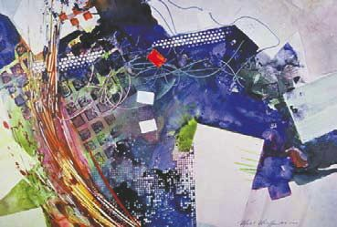

Registration instructions
Fee: FAA member: $230, Non-member $250
To REGISTER, Please send a non-refundable deposit of $40 along with the registration form below to Yuki Hall, 4136 Fox Fern Ct. Beavercreek, OH 45432. Make checks payable to FAA. The final payment must be made by Aug. 20th, 2015. For questions or more information, Call Yuki at (937) 426-7229, or e-mail yukihall@woh.rr.com

Please return this section with your deposit
Mark Mehaffey Workshop: Nov. 2nd - 5th , 2015 – presented by Fairborn Art Association

Name__________________________________
Address: ___________________________________________________ City: _______________________ State: ____________ ZIP:____________
Phone: ____________________ E-mail: _____________________________
$
Member Non-member Amount enclosed

