Watercolor Fresh & Fluid
With Yuki Hall, OWS
www.yukihall.artspan.com

Monday morning class (8 weeks) taught by Yuki Hall, ows
March 16th to May 18th, 2015, 9:30 – 12: 30 (class will not meet on April 27 & May 4) at Fairborn Art Association Gallery, located at the rear of the Fairborn Senior Apartment Building, 221 North Central Avenue, Fairborn, Ohio.

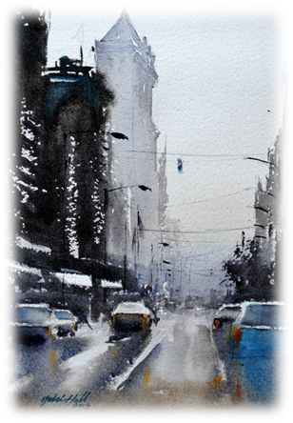
In this 8 weeks course, we will focus on painting variety of subject matters by fully utilizing the best quality of watercolor medium, the fluid quality. A special emphasis will be placed on incorporating an abstract factor into a representational painting, as well as fundamental concepts on composition and design principles.
Each session will start with a short lecture and a demonstration, followed by plenty of student’s painting time with individual assistance.
The main goal of this course is to help each student (at his/her own level) gain deeper understanding of the mechanisms of this mysterious and fascinating medium, so that she/he can start painting with more confidence and less frustration.
Yuki’s highly-organized, friendly, and non-intimidating teaching style has been well received for years by students of all levels.

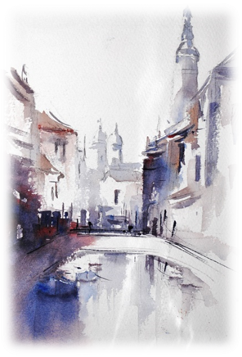
Yuki Hall is an award winning watercolor artist known for her loose style and spontaneous approach to working with the medium.
Her work has been accepted into various prestigious National & International level watercolor juried competitions including 38th National Juried Exhibition of Transparent Watercolor Society of America, Kenosha, WI and 46th Watercolor West International Juried Exhibition, Brea, CA, where she won the Founders Award.
Her work also have been and will be published by highly competitive national art/watercolor publications, including, two years in a row appearance (April 2014 & April 2015 issue ) in “Watercolor Artist Magazine” Watermedia Showcase, Splash 16 - Exploring Texture, (June 2015) North Light Book. Yuki was also one of the finalists in the “Artists Magazine” Annual Art Competition, 2013.

The cost for this 8-week class is $95. To register, please send the payment and the registration form below to Yuki Hall, 4136 Fox Fern Ct. Beavercreek, OH 45432. For any questions regarding this class, please call or e-mail Yuki at (937) 426-7229, yukihall@woh.rr.com www.yukihall.artspan.com
Please include this section in your payment
-------------------------------------------------------------------------------------------------------------------------------------------------------------------------------------------------
Registration Form:” Watercolor Fresh & Fluid by Yuki Hall, ows March 16 - May 18, 2015
Name
Address: ______________________________________________________________________________________________________________________________________
Phone: ______________________________ E-mail: __________________________________________________________________

