***Painting Trip to Cuyahoga Valley, Peninsula, OH***

***July 6 – July 8, 2015***

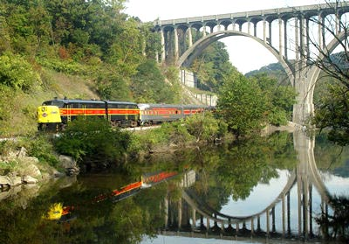

The cost involved in this trip is as follows.

* Hotel fee for two nights stay (July 6 & 7)

If you share a room with another person: $135 for 2 nights.

If you do not share a room with another person: $270 for 2 nights.

* Cost for your Meals (lunch & dinner only) Free Breakfast at the hotel. *Optional PB&J for lunch to save money.*
* Car-pool, gas money to the driver – approx. $20 - $30, depending on how many people are riding.
* $10 addmission fee if the group decide to paint in Hale Farm.

*\** ***In the event, the weather does not cooperate, we will***

***cancel the trip.***

Join us on this exciting three day trip to Cuyahoga Valley, Peninsula, OH for plein air painting, sketching, sightseeing and fellowship. We will depart early morning on July 6 and return late afternoon on July 8. Our friend Betty Derrer who has recently moved to Stow, OH will be joining us. We will be car-pooling both ways, and the driving time is approximately 3.5 hours, one way.

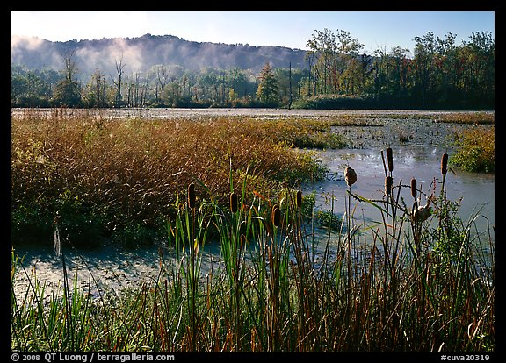

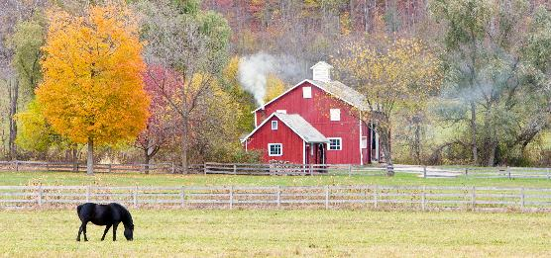

**Registration is necessary to join this trip. The space is limited - sign up early!**

**To sign up or for more information, please contact;**

**Yuki Hall at (937) 426-7229**

**yukihallfineart@gmail.com**