Watercolor Workshop with Tom Francesconi, AWS, NWS, TWSA Master
Presented by Fairborn Art Association
May 2nd to 5th (M – Th) 2016, 9 AM to 4 PM daily at the Fairborn Art Association Gallery, located in the rear of the Fairborn Senior Apartment Building, 221 N. Central Ave, Fairborn, OH

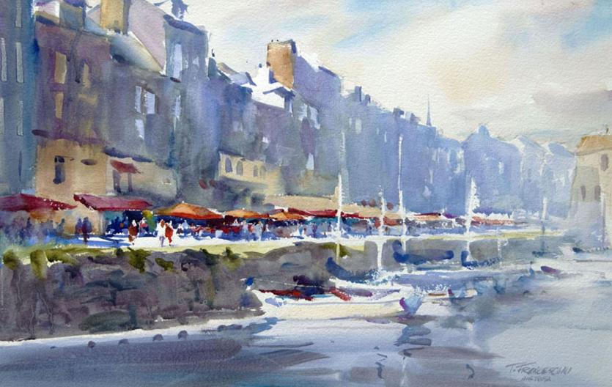
Tom’s energetic teaching style and his passion for painting combine to create a workshop experience that is enjoyable and informative. Any artist looking to break free of a careful, timid painting process will find Tom's direct and representational approach very inspirational. Utilizing his ability to clearly explain visual concepts, Tom will share his approach and methods for painting bold and interpretive watercolors. Within this process, students will learn how to create stronger, more effective visual statements.
Tom Francesconi is a nationally recognized artist, who studied watercolor at the American Academy of Art in Chicago. He has earned signature membership in numerous watercolor societies, including the American Watercolor Society, National Watercolor Society, Watercolor West and the Transparent Watercolor Society of America, of which he has been honored with ‘Master’ status. Tom has served as president of the Transparent Watercolor Society of America. He has received many awards in regional and national exhibitions, including the 1st Place Award at the 43rd Annual Watercolor West Exhibition and the Soft Edged Expressionism Award at the 32nd Adirondacks Exhibition of American Watercolors. For more information about Tom, visit his website at www.tomfrancesconi.com.
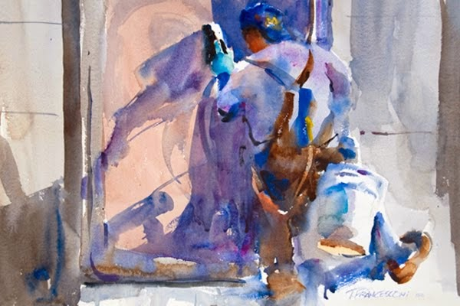

Registration instructions
Fee: FAA member: $230, Non-member $250
To REGISTER, Please send a non-refundable deposit of $40 along with the registration form below to Yuki Hall, 206 E. Holmes St. Urbana, IL 61801. Make checks payable to FAA. The final payment must be made by March 31, 2016. For questions or more information, Call Yuki at (937) 426-7229 or e-mail yukihallfineart@gmail.com.

Please return this section with your deposit
Tom Francesconi Workshop: May 2nd - 5th, 2016 – presented by Fairborn Art Association

Name__________________________________
Address: ___________________________________________________ City: _______________________ State: ____________ ZIP:____________
Phone: ____________________ E-mail: _____________________________
$
Member Non-member Amount enclosed

