Painting Atmosphere in Watercolor
With Yuki Hall, OWS
Wednesday morning class (8 weeks) taught by Yuki Hall, OWS
March 1 to April 26, 2017, 9:30–12: 30 (class will not meet on March 22)
at Fairborn Art Association Gallery
located at the rear of the Fairborn Senior Apartment Building
221 North Central Avenue, Fairborn, Ohio.

In this 8-week course, you will learn how to transform an ordinary scene into an atmospheric watercolor painting which will deliver an emotional impact to the viewers. Yuki will guide you through the way to paint boldly, bringing out the true quality of watercolor, such as spontaneity, freshness, and fluidity. The fundamental concepts and techniques of watercolor will also be covered. Strong emphasis will be placed on the importance of a pre-planning stage as well as effective use of strong tonal value pattern and edge qualities.

Yuki Hall is an impressionistic watercolor artist known for her spontaneous and loose approach to working with the medium by emphasizing simplified compositions and economy of brush strokes.

Yuki’s work has been accepted into various national & international level watercolor juried competitions including the 38th National Exhibition of Transparent Watercolor Society of America, and the 46th Watercolor West International Exhibition, where she won the Founders Award. Her works also have been published by highly competitive national art/watercolor publications: three consecutive years (2014, 2015 & 2016) in Watercolor Artist Magazine and Splash 16 - Exploring Texture (2015), North Light Books. To learn more about Yuki or to see some of her recent work, visit her website at www.yukihallfineart.com.
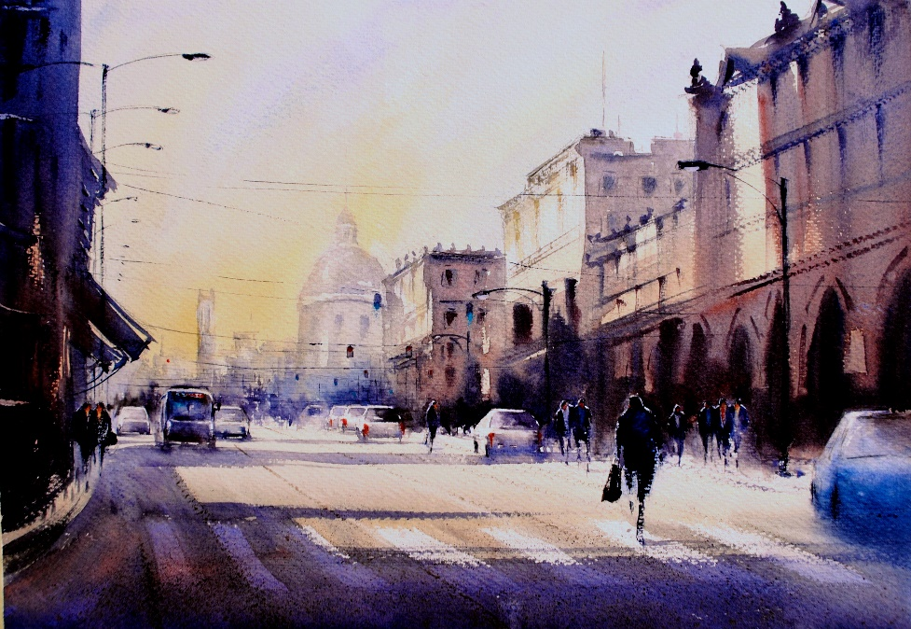

Yuki Hall is an impressionistic watercolor artist known for her spontaneous and loose approach to working with the medium by emphasizing simplified compositions and economy of brush strokes.
Yuki’s work has been accepted into various national & international level watercolor juried competitions including the 38th National Exhibition of Transparent Watercolor Society of America, and the 46th Watercolor West International Exhibition, where she won the Founders Award. Her works also have been published by highly competitive national art/watercolor publications: three consecutive years (2014, 2015 & 2016) in Watercolor Artist Magazine and Splash 16 - Exploring Texture (2015), North Light Books. To learn more about Yuki or to see some of her recent work, visit her website at www.yukihallfineart.com.

The cost for this 8-week class is $105. To register, please send the payment and the registration form below to Yuki Hall, 4136 Fox Fern Ct. Beavercreek, OH 45432. For any questions regarding this class, call or e-mail Yuki at (937) 426-7229, yukihallfineart@gmail.com, Please include this
-------------------------------------------------------------------------------------------------------------------------------------------------------------------
Registration Form: “Painting Atmosphere in Watercolor” by Yuki Hall, ows

Name_______________________________________________________________________________________
Address: ___________________________________________________________________________________
Phone: ______________________________ E-mail: _____________________________________

