THE WESTERN OHIO WATERCOLOR SOCIETY
Vladislav Yeliseyev
“Urban Landscape Workshop”

October 6-7 2017
9:30am -4:30pm
$225.00

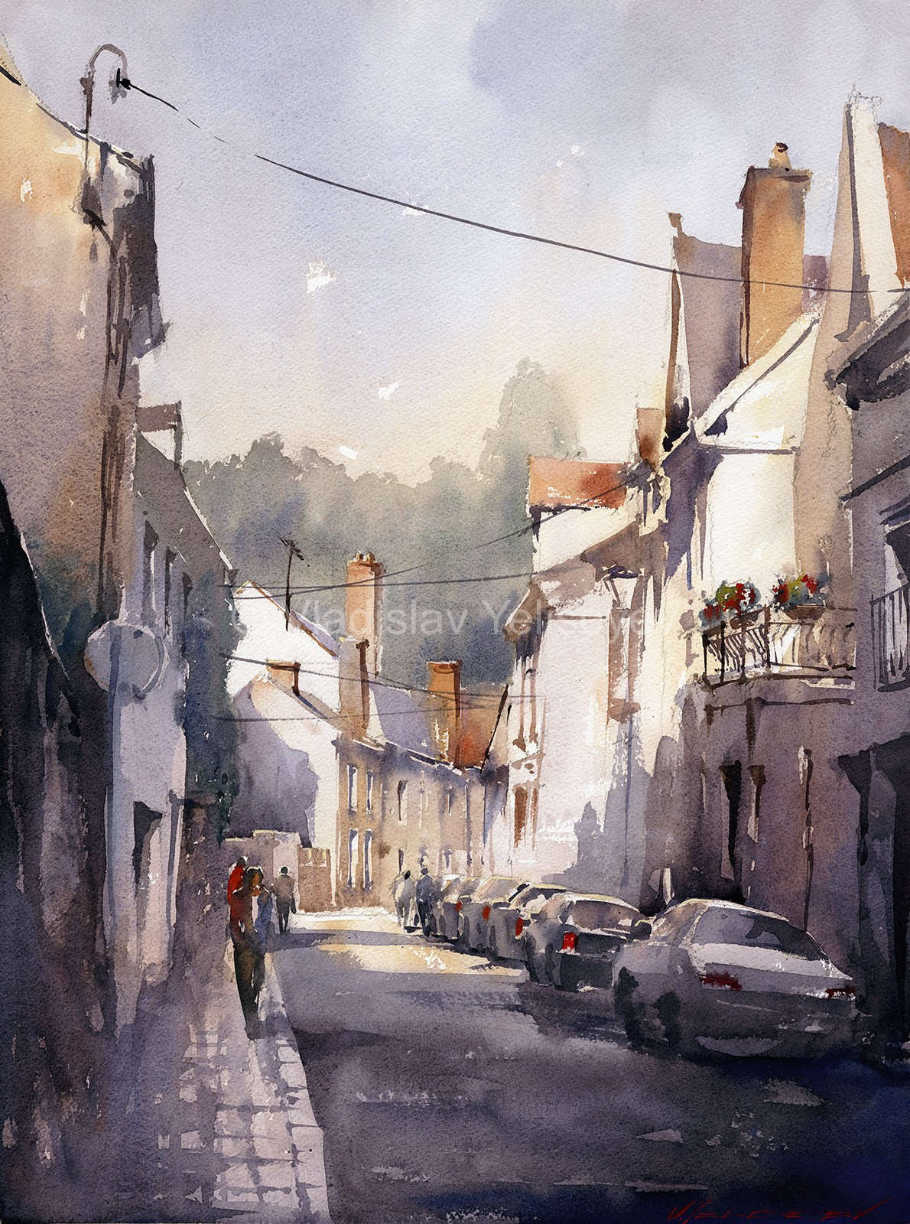

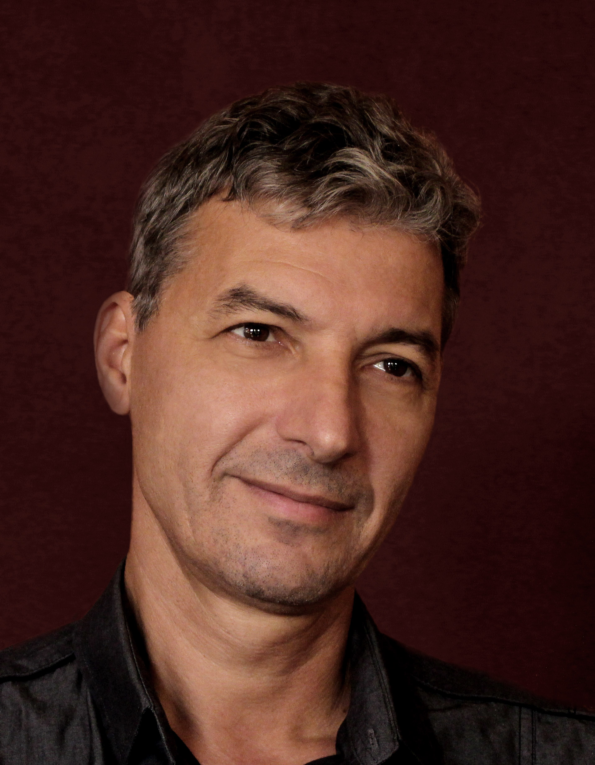
What is required to quit tight illustrative coloring which is a trademark of beginners and start painting like a pro? All of this and many other techniques will be the subject of this intensive workshop.
Like Vladislav says “nobody wants to buy my cellphone photographs despite the wealth of detail and accurate colors”. You are going to learn how to mix and apply watercolors without fear of being inaccurate. Vlad will show you the shortcuts to the path when every brushstroke applied is significant in its impact on the viewer. He will show you importance of one detail above the other and therefore how to be selective in your painting process. Every painting is like a poetry, the less words wasted the more powerful message it conveys. On the technical side of things you will learn how to approach urban scenery and what are the major steps involved in achieving artistic results. Basics on where the discipline is required to complete the painting versus to where it is better to give up and flow with your inspiration.
First day: studio practice - the basics of cityscape painting process. We will paint small postcard size images in grisaille and color. Lecture will be implemented with the sample explanations.
Day two: plein air - practical implementation of the knowledge acquired in studio with little demo at the beginning of the day. The workshop ends with group critique highlighting success and areas for improvement.
We look forward to seeing you at the workshop!
The workshop will be held at The Vineyard Church, 4051 Indian Ripple Road, Beavercreek, Ohio from 9:30 am to 4:30 pm, with a one hour lunch break.

Registered artists will receive, via email, a suggested supply list, directions to the church, lodging suggestions etc.

Please send the form with your payment to:

Robine Wright: 1515 N. Fountain Blvd. Springfield, OH 45504 rlwright090587@yahoo.com

Make checks payable to the Western Ohio Watercolor Society for the full amount due of:

$225.00

Cancellation and refund policy information can be found on the WOWS website:
www.westernohiowatercolorsociety.org

DETACH HERE-----------------------------------------------------------------------------------------------
Name:________________________________________________________________

Address:______________________________________________________________

City, State, Zip:_________________________________________________________

Phone:_____________________________

Email:___________________________________

Amount enclosed:______________________________________Member_______________

