Lian Quan Zhen Workshop at Fairborn Art Association - May 2-4, 2018
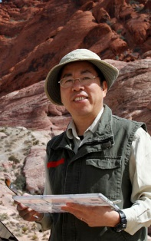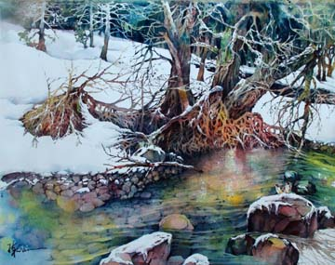
Lian Quan Zhen is a sought-after watercolor and Chinese painting artist and teacher in the US and abroad. He is one of the most popular authors of North Light Books.
He started sketching and painting in his childhood and continued as a hobby while practicing medicine as a family physician in Canton Province, China. After immigrating to the US in 1985, he obtained a Bachelor of Arts Degree from University of California at Berkeley in 1992 and a Master of Architecture Degree from MIT in 1996. He has had many shows in the US, Hong Kong and China and developed an international following. His paintings hang in numerous institutional and private collections including the MIT Museum which has collected 14 of his paintings.
His art teaching credentials include at the University of California at Berkeley where he taught watercolor outdoor sketching for 8 years; watercolor and Chinese painting workshops nationwide in the US, and other countries in Europe, Canada, Mexico, Bahamas, China, South Africa and Australia. (See http://www.lianspainting.com/workshops.htm for additional information on his workshops and a list of art supplies.) Also, Lian has been an invited juror for California, Colorado, New Mexico, Georgia, Arizona and Kentucky Watercolor Societies' exhibitions and other local shows. His paintings have been featured in magazines such as Watercolor 94 Spring, Splash4, Collectors (Hong Kong) and books of Landscape on Watercolor (UK), Finding Your Visual Voice, and Painter's Quick Reference books by North Light Books: Flowers and Blooms, Dogs and Cats, Birds and Butterflies, Landscapes, and Drawing and Painting Animals - the Essential Guide.
Registration Fees: FAA Member-$250 Non-member-$275
To Register: Please send a non refundable deposit of $40 along with the following form to : Pat Dunker, 30 Innisbrook Close, Xenia, Oh 45385
Make checks payable to FAA. Final payment must be made by 4/21/18.
For questions; Call Pat Dunker at (937-562-3014) or cell (937-271-4798) or email pwdunk@gmail.com
+++++++++++++++Please return this form with non refundable deposit or full payment +++++++++++++++++++++++++++++++++++++++++++++
Lian Zhen Workshop May 2-4, 2018 presented by FAA 9:30-4:00 PM located in the Gallery

In the rear of the Fairborn Senior Apartment Building, 221 N Central Ave. Fairborn, Oh 45434
NAME:_________________________________________________
ADDRESS____________________________________________________ CITY__________________________
PHONE____________________________ STATE_________________________ ZIP_______________
EMAIL:_____________________________
3 DAY CLASS $250-MEMBER [ ], $275-NON-MEMBER [ ] AMOUNT ENCLOSED_____________________________

