Creating Infinite Depth in Watercolor Landscape
With Buong-Kil Juong
Watercolor landscape painter from Korea, Buong-Kil Juong, will present a three-day workshop March 9-11, 2015, Monday through Wednesday, 9:30-4:00 pm at the Fairborn Art Association Gallery. He will lead the class with his masterly wet on wet method to portray his beloved country side landscape over four seasons. Misuk Goltz took a one week private lesson from him in Jae Cheun City from January 2-8 this year and she will be hosting his stay in the US, translating, and assisting with his presentation.
The tuition will be $200 for the three-day workshop for FAA member and $220 for non-members. The workshop needs at least 20 participants to cover the artist’s air fair and lesson fee. If you are interested in this workshop, please register by sending a non refundable $50 deposit by the first week of February to Misuk. As of today, there are 11 spots available. In the event the workshop is cancelled, you will be fully refunded your deposit. Please send your registration with your name, email address and phone number to: Misuk Goltz, 2489 Sherbourne Way, Xenia, OH 45385. Contact Misuk, mgoltz@woh.rr.com, (937)352-6711, for any questions.
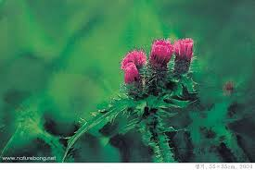
“My painting begins the moment my eyes land on nature when I visit the country side and mountains.

I visit them as soon as the day breaks so I can listen to every bit of their thoughts and voices.

I diligently look for changes in their sounds and colors.
Without knowing nature, I don’t think I can paint, even a fraction.
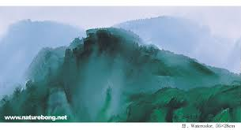
I feel soaring energy of life from the green in May,
I see endless depth of life in the summer hills,
I feel tranquility of life from a late autumn field,
I see profundity of life from snow covered winter.
I desire to understand echoes of the earth in each season; therefore I can paint.”

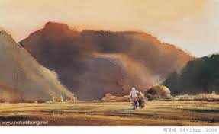
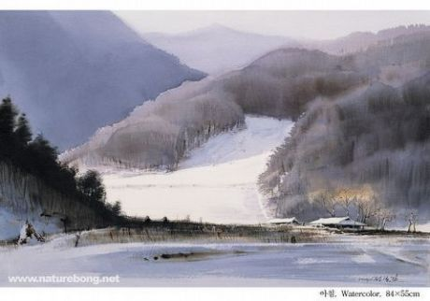
Buong-Kil Juong was born in South Korea and studied art from high school through college. He has been painting watercolor for the past 35 years and serves important positions in the Korean Watercolor Society and various educational associations. He has been teaching and serving as a juror for many art competitions. He also is regarded as a respected watercolor artist in China and he has held many exhibitions in various Chinese cities. He lives in Jae Cheun City, South Korea.

