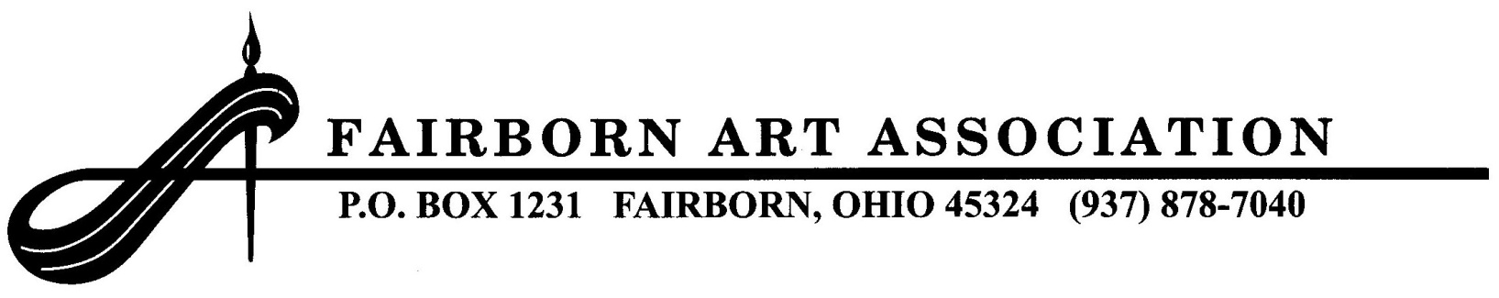2015 MEMBERS’ SPRING FINE ART SHOW
Judge: Frank Francese, NWS, TWSA Master

ELIGIBILITY: This show is open to all F.A.A. members. All works entered will be displayed unless judge or committee decides otherwise. Artwork may be paintings in acrylic, oil, watercolor, drawing, pastel, pen & ink, photography, and 3D work in sculpture, hand-blown pottery or wood. Artwork to be hung must be suitably wired (no toothed hangers) and securely framed; size no larger than 28x38 including frame. It must be easily moveable by one person. All work must be original. It may not be a copy of a work by another artist, or a copy of another picture or photograph that has appeared in print. Works must be the artist's own concept, composition, and execution. Sorry, no nudes, prints, or computer-generated work permitted in this show. Three-dimensional work must be stable and not hazardous to the public. All entries must remain on display in the Gallery through the entire show.

ENTRY FEES: Entry fee for each piece of artwork is $10; maximum of three entries.

DELIVERY & PICK UP: Registration will be held Monday, April 27 from 9 am–12 noon and from 1–3 pm; and Wednesday, April 29 from 10 am–12 noon. The Members' Spring Fine Art Show will be on display in the F.A.A. Gallery on Sundays, May 3, 10, and 17, 2015, from 1–4 pm. Pick up artwork on May 17 from 4–5 pm or May 18 from 10 am–12 noon. Two pieces may be left for the Popular Choice Judging and Awards at the F.A.A. June Social on Tuesday, June 2, 2015. All items must be picked up after the Social.

AWARDS: Best of Show - $150, First Place - $100, Second Place - $75, Third Place - $50, eight Honorable Mention Awards at $25 each, and eight Judge's Merit Award Ribbons. There is a limit of one monetary prize per artist. Awards will be presented at the Tuesday, May 5, 2015 F.A.A. meeting.

SALES & INFORMATION: The sale of artwork to the public is encouraged. If the work is not for sale, it should be marked NFS. Please sign up to sit the Gallery for one Sunday in May. Please bring your completed entry form shown below with your entries. All possible care will be used in handling the artwork. No loss or damage will be assumed by the F.A.A., its officers, or agents. For further information, contact Robert or Gayle Beireis at 937-390-1992 or artwoman2@att.net.

