LIAN QUAN ZHEN WORKSHOP AT
FAIRBORN ART ASSOCIATION
NOV. 1-4, 2021

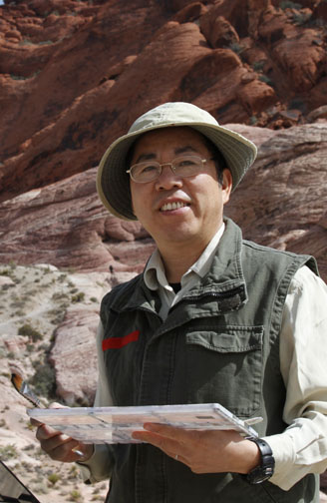 | Lian Quan Zhen is a sought-after watercolor and Chinese painting artist and teacher in the US and abroad. He is one of the most popular authors of North Light Books.  He started sketching and painting in his childhood and continue as hobby while practicing medicine as a family physician in Canton Province, China. After immigrating to the US in 1985, he obtained a Bachelor of Arts Degree from University of California at Berkeley in 1992 and a Master of Architecture Degree from MIT in 1996. He has many shows in the US, Hong Kong and China and developed an international following. His paintings hang in numerous institutional and private collections including the MIT Museum which has collected 14 of his paintings.  His art teaching credentials include at the University of California at Berkeley where he taught watercolor outdoor sketching for 8 years; watercolor and Chinese painting workshops nationwide in US, and other countries in Europe, Canada, Mexico, Bahamas, China, South Africa and Australia. Also, Lian has been an invited juror for California, Colorado, New Mexico, Georgia, Arizona and Kentucky Watercolor Societies' exhibitions and other local shows. His paintings featured in magazines such as Watercolor 94 Spring, Splash4, Collectors (Hong Kong) and books of Landscape on Watercolor (UK), Finding Your Visual Voice and Painter's Quick Reference books by North Light Books: Flowers and Blooms, Dogs and Cats, Birds and Butterflies, Landscapes and Drawing and Painting Animals - the Essential Guide.
In this work shop Lian will be teaching two days of Chinese painting and two days of his original style, He would like each student to have the necessary Chinese painting materials which includes paints, brushes etc.
The cost for these is $35 which is very reasonable. You may register for one below so he brings enough sets.

To Register: Please send a NON-REFUNDABLE deposit of $40 along with the following form to :  Pat Dunker, 30 Innisbrook Close, Xenia, Ohio 45385  Make checks payable to FAA. Final payment must be made by10/25/21. After that date, tuition is non-refundable  For questions; Call Pat Dunker cell (937-271-4798) or email pwdunk@gmail.com |  |  |  |  |  |  |  | Zip:______________
+++++++++++++++Please return this form with non refundable deposit or full payment +++++++++++++++++++++++++++++++++++++++++++++
LIAN QUAN ZHEN Workshop NOV 1-4, 2021, presented by FAA 9:30-4:30 PM located in the Gallery in the rear of the Fairborn Senior Apartment Building, 221 N Central Ave. Fairborn, Oh 45434

NAME:_________________________________________________ PHONE____________________________
ADDRESS____________________________________________________ CITY__________________________
STATE_________________________ ZIP_______________EMAIL:_______________________________________
4 DAY CLASS-$ 275MEMBER [ ], $300-NON-MEMBER [ ] Amount Enclosed________________________________
Chinese painting supply kit $35 ___________________YES _______________________NO

