DAVID R. SMITH WORKSHOP
AT FAIRBORN ART ASSOCIATION
MAY 2-4, 2022

David enjoys the challenge of working in harmony with a fluid medium. By providing the proper environment, surrendering some control, and working with the medium, the most beautiful results oftentimes occur naturally. To keep the paintings from getting too precise, and instead, to convey a feeling of aliveness, David utilizes a number of techniques such as working wet into wet, glazing, pouring, spattering, and spraying. These techniques not only keep the painting fresh, but produce exciting interminglings and textures effortlessly.

David’s favorite subjects tend to be found in nature and he loves to travel abroad as well as explore state and national parks for inspiration. Depicting a subject in great light, capitalizing on the contrast developed by light and shadow, while showcasing the assortment of jewels that happen naturally through the fluid medium keeps David eager to paint his next creation.

David has studied under numerous instructors in the states and in China. He has displayed his work in galleries and museums across the United States and his work has been awarded at the state and national level. David has received Signature Membership with the American Watercolor Society, National Watercolor Society, and others.

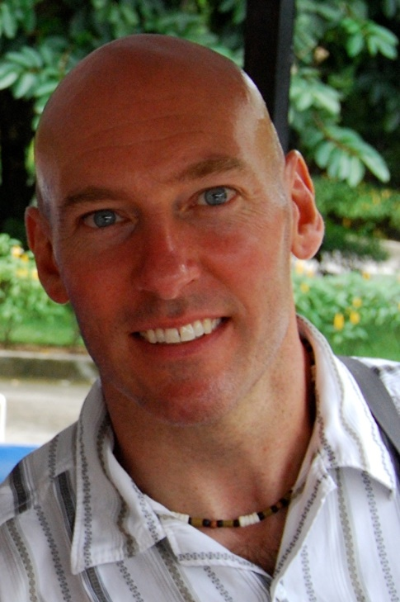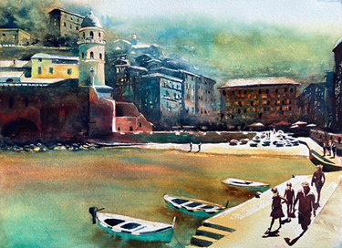

To Register: Please send a NON-REFUNDABLE deposit of $40 along with the following form to:
Pat Dunker, 30 Innisbrook Close, Xenia, Ohio 45385
Make checks payable to FAA. Final payment must be made by 4/25/22. After that date, tuition is non-refundable.
For questions: Email Pat Dunker at pwdunk@gmail.com

++++++++++++++++++Please return this form with non-refundable deposit or full payment++++++++++++++++++

DAVID R. SMITH Workshop MAY 2-4, 2022

Presented by FAA 9:30 AM -4:30 PM located in the Gallery in the rear of the Fairborn Senior Apartment Building, 221 N. Central Avenue, Fairborn, OH 45434

NAME_____________________________________________PHONE____________________________________
ADDRESS_________________________________________ CITY______________________________________
STATE______________________________ZIP____________EMAIL____________________________________
3 DAY CLASS- $325 MEMBER [ ], $350 NON-MEMBER [ ] AMOUNT ENCLOSED _______________________

